**What is SDLC**

**SDLC – software development life cycle**

• What is agile methodology?

**Agile is combination of iterative and incremental process model for SDLC**

• What is SRS

**SRS mean - A software requirements specification (SRS) is a document that describes what the software will do and how it will be expected to perform.**

• What is oops

**OOPs mean Object-oriented Languages**

• Write Basic Concepts of oops

**There are six concepts of Object-oriented programming – Object, Class, Encapsulation, inheritance, Polymorphism, Abstraction**

• What is object

**An Object is anything to which a concept applies.**

• What is class

**Class is a blueprint for an object**

• What is encapsulation

**Encapsulation mean that all important information is contained inside an object and only select information is exposed.**

• What is inheritance

**Inheritance is the relationship between two classes. A class can get some of its characteristics from a parent class and then add unique features of its own**.

• What is polymorphism

**Polymorphism means a variable, function, or object having many forms.**

• What is RDBMS

**RDBMS means Relational Database Management System (RDBMS) Its stand for The software used to store, manage, query, and retrieve data stored in a relational database**

• What is SQL

**SQL means Structured Query Language**

• Write SQL Commands

**SQL Commands**

1. **DDL- data definition language**

* **Create**
* **Alter (modify)**
* **Drop (remove)**

1. **DML- Data Manipulation Language**

* **Update**
* **Delete**

1. **DCL- Data control Language**

* **Grant**
* **Revoke**

1. **DQL- Data Query Language**

* **Select**
* **Insert**

• Write SDLC phases with basic introduction

1. **Requirements – check with customer’s what they need features, usage scenarios as functional (mean services or functions Ex. compute sales tax on a purchase, update the database on server) or non-functional (mean constraints on the system or development process) by gathering information in written form, constant feedback, because there are mainly 3 types of problem can rise. * Lack of Clarity *requirements of confusion * requirements amalgamation.**
2. **Analysis- try to as per requirements identifies any potential risks. This phase starts with the requirement document delivered by the requirement phase and maps into architecture.**
3. **Design – The design team expand upon the information established in the requirement document and decribes how each and every feature in the product should work. It’s also in this phase when the database specification is developed to decide on which model it will work. Its include Implementation plan, Critical Priority Analysis, Performance Analysis, Test plan. This phase team also converts the typical scenarios into a test plan.**
4. **Implication – This phase deals with issues of quality, performance, baselines, libraries and debugging and the team should build exactly what has been requested, though there is a still room for innovation and flexibility.**
5. **Testing Phase: to check whether the system is running according to the requirement of the customer/client. Its include Regression, Internal, Unit, Application and Stress testing.**
6. **Maintenance Phase: This phase which comes after delivered to client of the software into the field. Its also consider as task of maintenance starts as when the client will come up with an error like they have some mechanism to document and track defects and deficiencies this issue should be fixed from time to time. As configuration and version management by reengineering, redesigning, refactoring, updating all analysis, design and user documentation.**

• Explain Phases of the waterfall model.

**The Waterfall Model was the first Process Model to be introduced.**

* **Waterfall model is used only when the requirements are very well known in advance, clear and not supposed to change in future.**
* **Product definition is stable.**
* **Technology is understood.**
* **There are no ambiguous requirements.**
* **Ample resources with required expertise are available freely.**
* **The project is short.**

**The waterfall model works well for smaller projects where requirements are very well understood**

**Advantages of the Waterfall Model**

* **This model progresses through easily understandable and explainable phases and thus it is easy to use.**
* **It is easy to manage due to the rigidity of the model – each phase has specific deliverables and a review process.**
* **In this model each phase must be completed before the next phase can begin and there is no overlapping in the phases.**
* **Process and results are well documented.**

**Disadvantages of Waterfall Model**

* **It is difficult to estimate time and cost for each phase of the development process in waterfall model.**
* **Once an application is in the testing stage, it is very difficult to go back and change something that was not well-thought-out in the concept stage. (cannot accommodate changing requirements)**
* **Not a good model for complex and object-oriented projects.**
* **Not suitable for the projects where requirements are at a moderate to high risk of changing. (High amount of risk and uncertainty.)**
* **The outcome of one phase acts as the input for the next phase sequentially. This means that any phase in the development process begins only if the previous phase is complete.**
* **Disadvantage of this model is the whole process of *software development* is divided into separate phases**

• Write phases of spiral model

**A project passes through all these stages repeatedly and the phases are known as a Spiral in the model. It has four stages or phases:**

1. **Planning- ( Determine objectives and find alternate solutions) – This phase includes requirement gathering and analysis. Based on the requirements, objectives are defined and different alternate solutions are proposed.**
2. **Risk Analysis and resolving – In this quadrant, all the proposed solutions are analyzed and any potential risk which will delay project or increase its cost is identified, analyzed, and resolved.**
3. **Develop and test: This phase is also known as Engineering where the next level of the product development start. This phase includes the actual implementation of the different features. All the implemented features are then verified with thorough testing.**
4. **Review and planning of the next phase (customer evaluation) – In this phase, the software is evaluated by the customer. It also includes risk identification and monitoring like cost overrun or schedule slippage and after that planning of the next phase is started.**

## **Spiral Model Advantages**

* **This model supports the client feedback and implementation of change requests**
* **Users see the system early.**
* **Since customer gets to see a prototype in each phase, so there are higher chances of customer satisfaction.**
* **Development can be divided into smaller parts and more risky parts can be developed earlier which helps better risk management.**

## **Spiral Model Disadvantages**

1. **Because of the prototype development and risk analysis in each phase, it is very expensive and time taking. So end of project may be not know early.**
2. **It is not suitable for a simpler and smaller project because of multiple phases and process is complex.**
3. **It requires more documentation as compared to other models because in this model large number of intermediate stage requires excessive documentation.**
4. **Project deadlines can be missed, may go indefinitely**

• Write agile manifesto principles

**The Agile Manifesto is a document that developers should use to guide their work. Its include identifies four key values and 12 principles.**

**The four core values of Agile Manifesto are:**

#### **1. Individuals and interactions over processes and tools**

**This value of the Agile manifesto focuses on giving importance to communication with the clients.in agile development responsibility of the team members to ensure that all questions and suggestions of the clients are promptly dealt with. So as member its self- organization with motivation to deal with customer promptly. And this is part of already what you programmed to pair new programme ( as per client new requirement or implantation )with it.**

#### **2. Working product over comprehensive documentation**

**In the past, more focus used to be on proper documentation of every aspect of the project. And it increase expense of the final product. The Agile Demo working software so the project team is completing the final deliverables as identified by the customers need. Its depended-on communication not on just documentation.**

#### **3. Customer collaboration over contract negotiation**

**Agile principles require customers to be involved in all phases of the project. The**[**Waterfall approach**](https://kissflow.com/project/agile/traditional-vs-agile-project-management/)**or Traditional methodologies only allow customers to negotiate before and after the project. This used to result in wastage of both time and resources. If the customers are kept in the loop during the development process, team members can ensure that the final product meets all the requirements of the client.**

#### **4. Responding to change over following a plan**

**Agile development is focused on quick responses to change and continuous development so project managers and their teams must adapt quickly in order to deliver a quality product and ensure 100% customer satisfaction.**

• What is join?

JOIN is an SQL clause used to query and access data from multiple tables, based on logical relationships between those tables.

In other words, JOINS indicate how SQL Server should use data from one table to select the rows from another table.

• Write type of joins.

**There are four main types of JOINs in SQL:**

1. **Inner Join: Inner Join clause in SQL Server creates a new table (not physical) by combining rows that have matching values in two or more tables.**
2. **Left Join: The LEFT JOIN command returns all rows from the left table, and the matching rows from the right table. The result is NULL from the right side, if there is no match.**
3. **Right join:The RIGHT JOIN command returns all rows from the right table, and the matching records from the left table. The result is NULL from the left side, when there is no match.**
4. **Full Join The SQL FULL JOIN combines the results of both left and right outer joins. The joined table will contain all records from both the tables and fill in NULLs for missing matches on either side.**

**• Explain working methodology of agile model and also write pros and cons.**

**In English, Agile means ‘the ability to move quickly and easily’ and respond to change rapidly – this is an important aspect of Agile software development.**

**The Agile methodology is a way to manage a project by breaking it up into several phases. Software develops in incremental, rapid cycles. It involves constant collaboration with stakeholders and continuous improvement at every stage.**

**Advantages of Agile Methodology :**

1. **Customers can have a look of the working feature which fulfilled their expectations.**
2. **The customers are satisfied because after every Sprint working feature of the software is delivered to them.**
3. **Changes in the requirements are accepted even in the later stages of the development.**
4. **In Agile methodology the delivery of software is unremitting.**
5. **If the customers has any feedback or any change in the feature then it can be accommodated in the current release of the product.**
6. **In Agile methodology the daily interactions are required between the business people and the developers.**
7. **In this methodology attention is paid to the good design of the product.**

**Disadvantages of the Agile Methodology :**

1. **In Agile methodology the documentation is less.**
2. **Sometimes in Agile methodology the requirement is not very clear hence it’s difficult to predict the expected result.**
3. **In few of the projects at the starting of the software development life cycle it’s difficult to estimate the actual effort required.**
4. **Because of the ever-evolving features, there is always a risk of the ever-lasting project.**
5. **For complex projects, the resource requirement and effort are difficult to estimate.**

• Draw usecase on Online shopping product using COD. (same as pay gatewat)

• Draw usecase on Online shopping product using payment gateway (same as online book shoping)

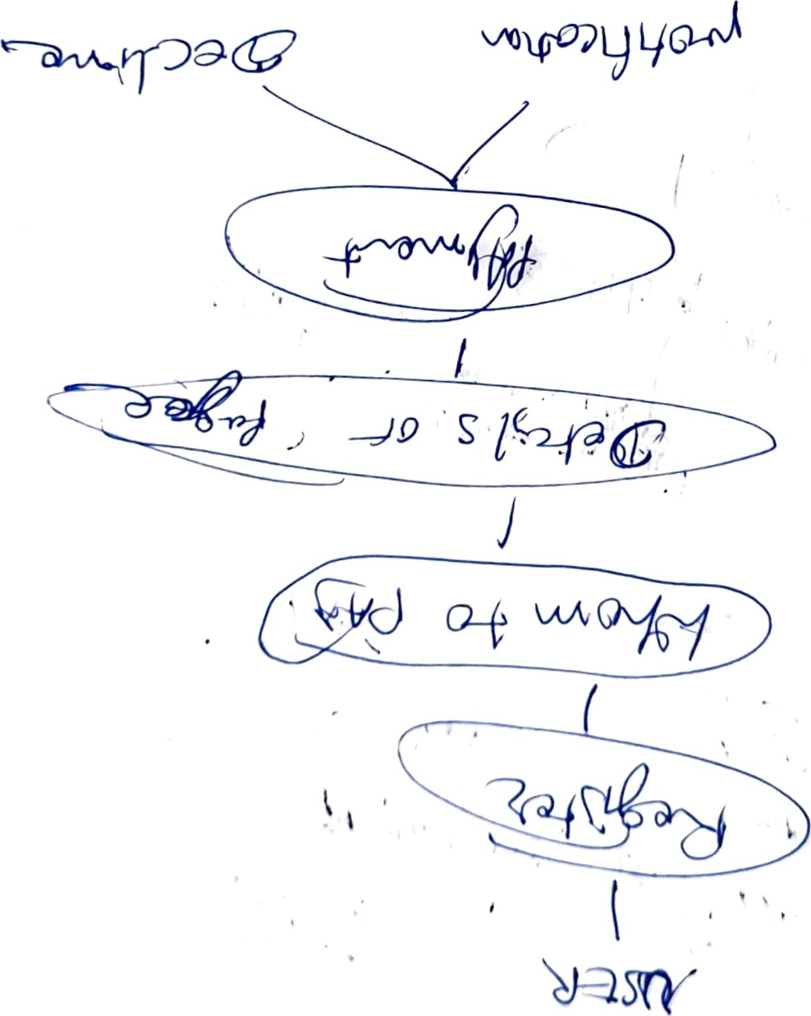

90/(7 [vo

• Draw Usecase on Online book shopping

